RUAP – LV2, Toni Kunštek, https://github.com/KunstekT/RUAP-LV2

Exercise 1:

Task 2:

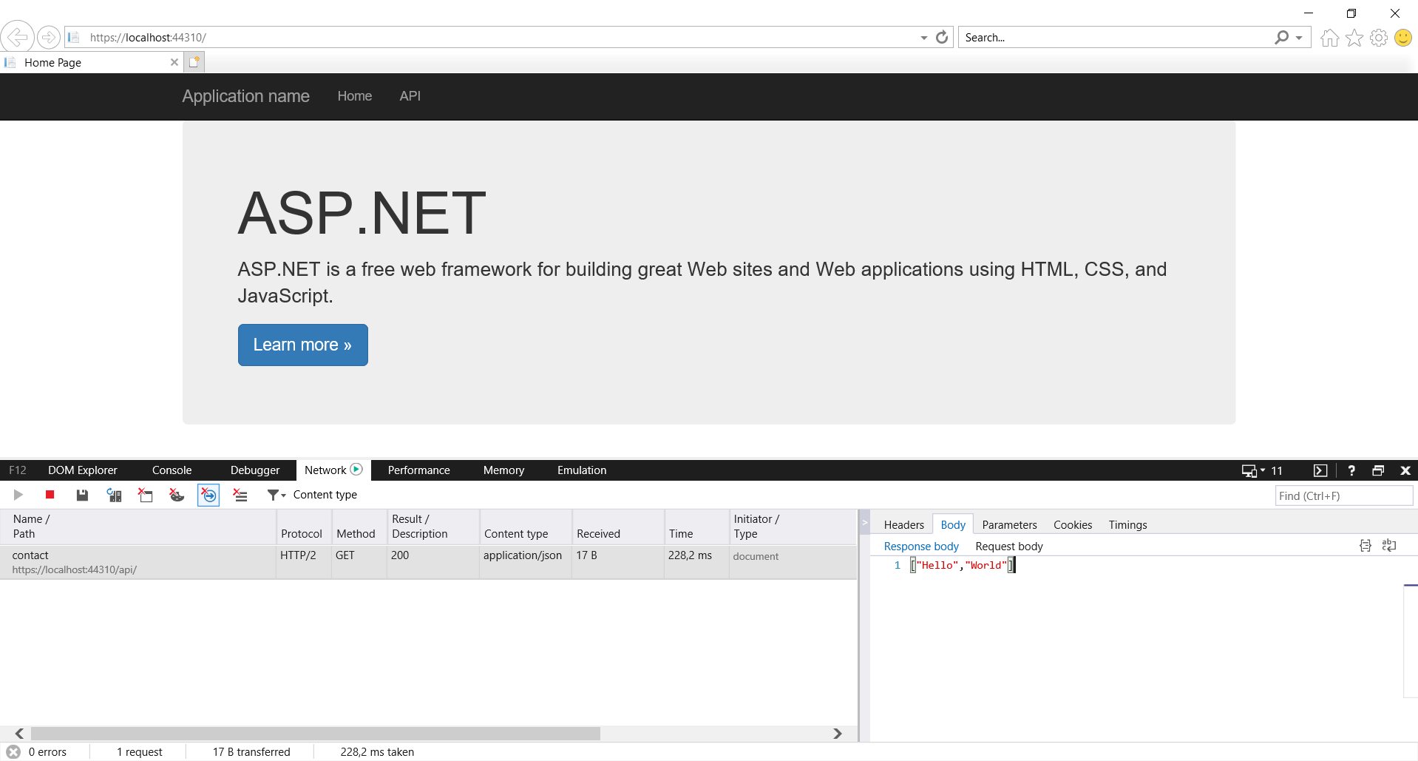

Task 3: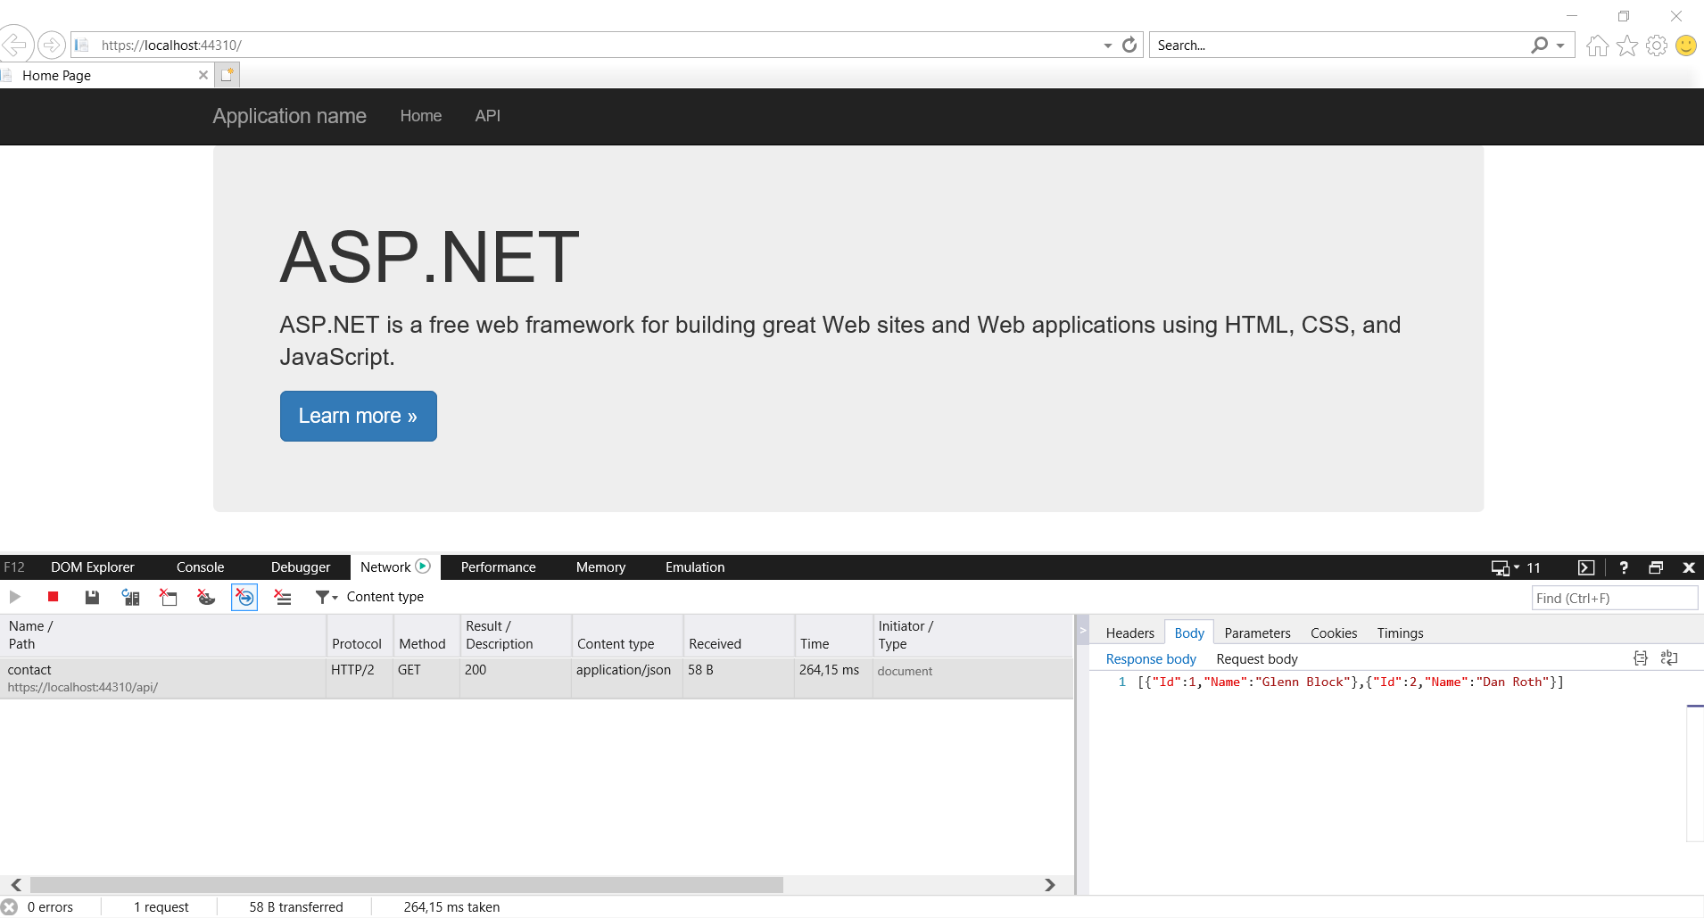

Task 4:

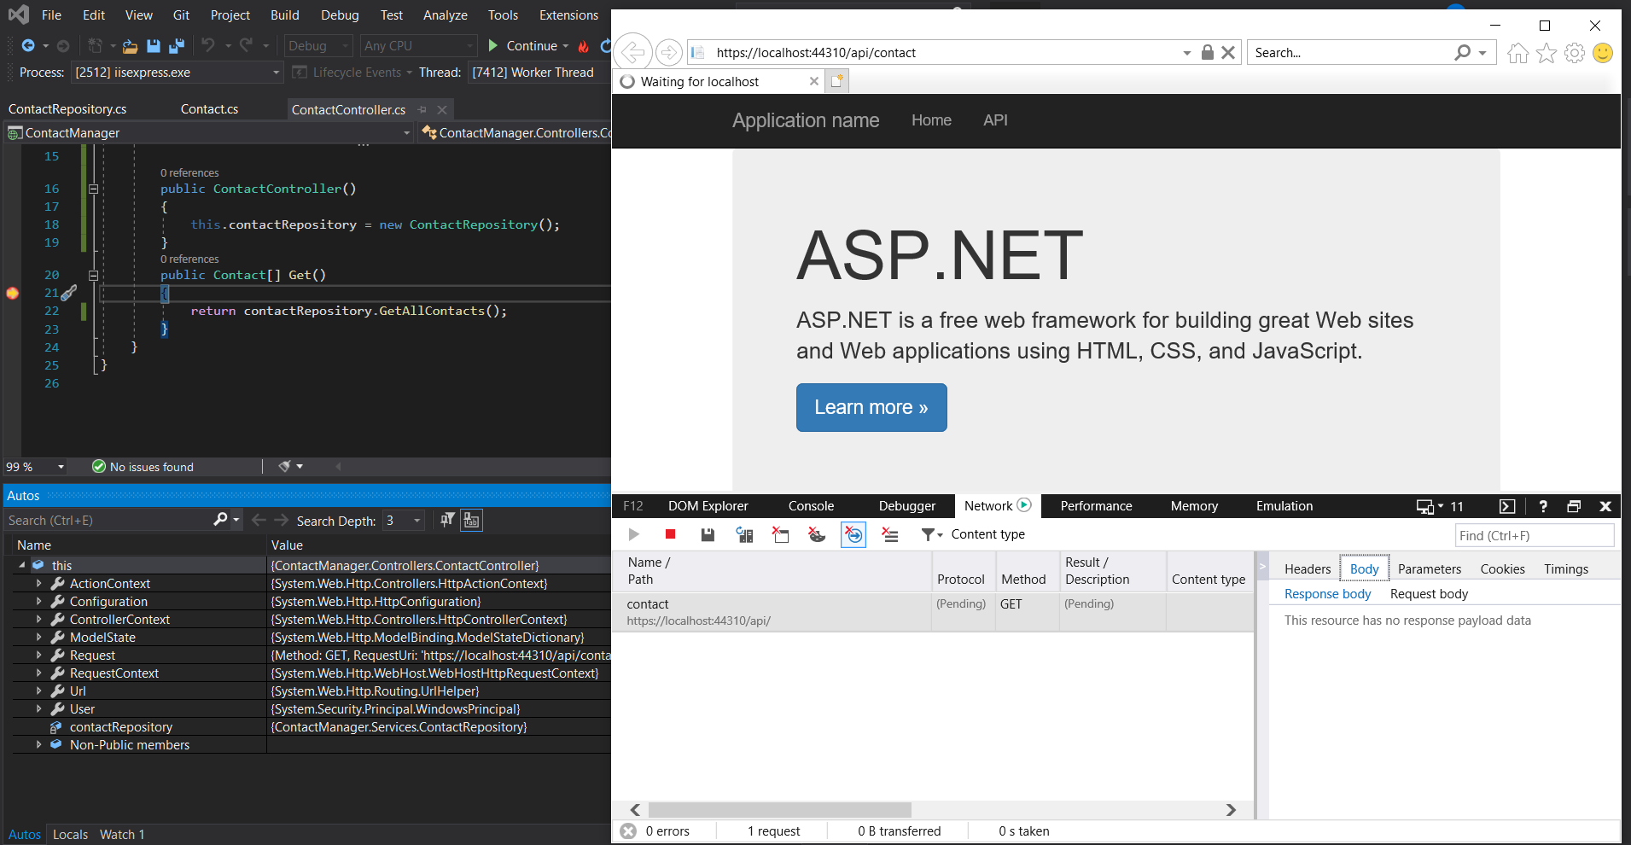

Exercise 2:

Task 1:

Task 2:

Exercise 3:

Task 1:

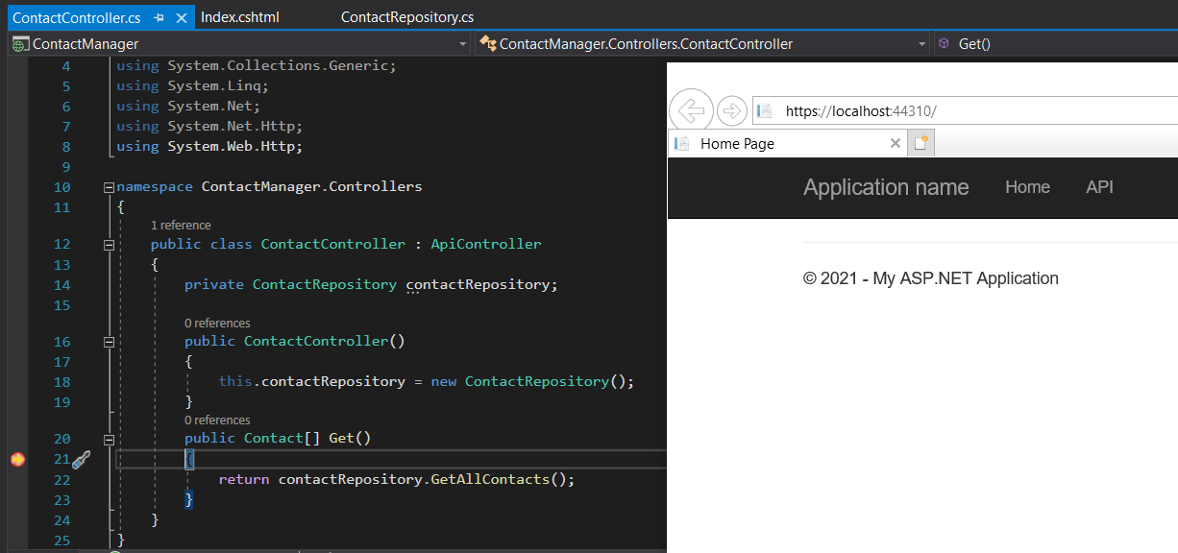

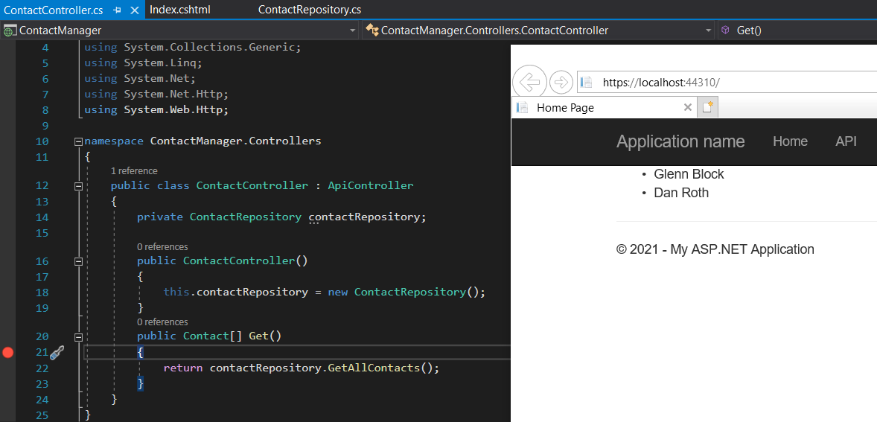

Task 2:



